To test our algorithm, we will first read drop attribute which she does not influence the result



Secondly , we need to divide the data into two samples. And

then see the results.

* 60% for the train. (28916, 6)
* 40% for the test. (19278 , 1)

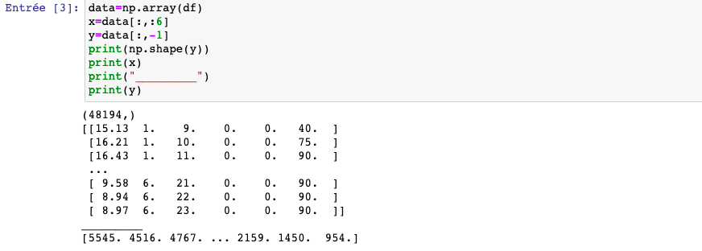

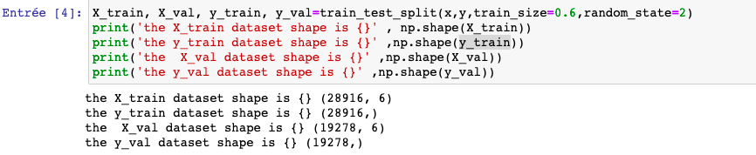

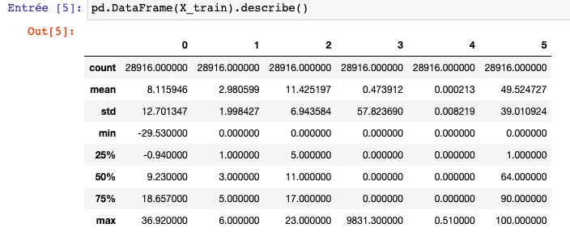

this instruction allowed to describe our data

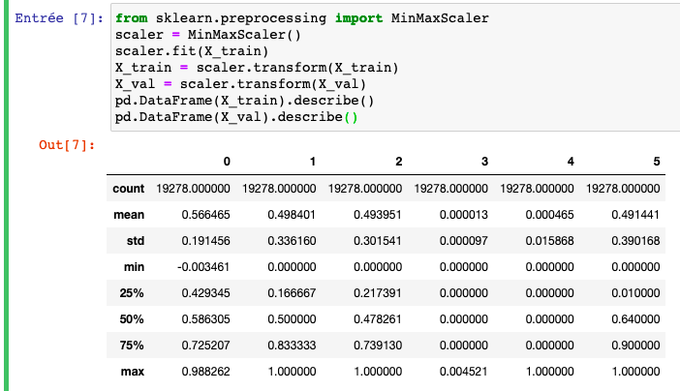

This estimator scales and translates each feature individually such that it is in the given range on the training set, e.g. between zero and one.

In our case, using a perceptron multi-layered network (MLPRegressor) which is used there to predict

* Using an ANN with 2 hidden layers with 50 number of nodes
* 6 input is number of variables and 1 output

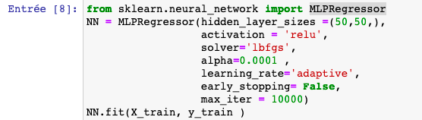

❖ Results

After implementing and executing our method as it is expressed, we got a precision:

❖ 93.58 % for the learning set,

❖ 93,88 % for the entire validation

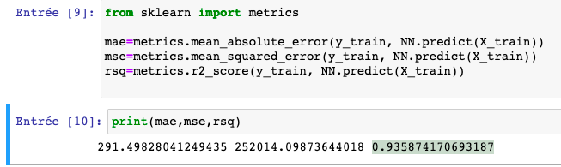

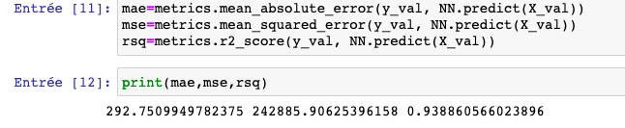

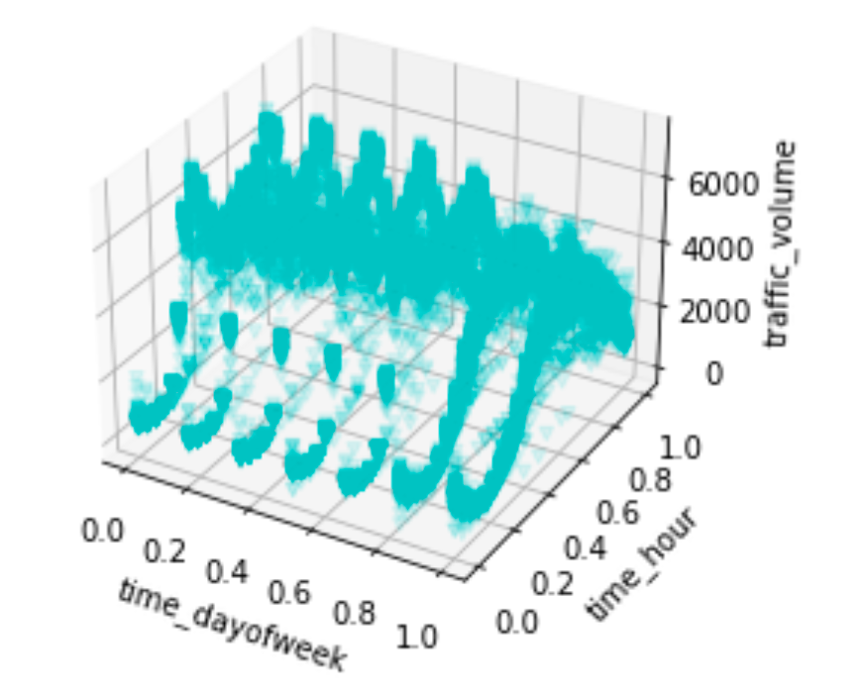

Comparison of methods:

During the analysis of the prediction results and the accuracy of the two models we found that the best

model to predict and detect traffic volume areas in is the Neural Networks model, because it gives us a better

prediction and very close learning and validation are 93% no underfitting our overfitting compared to the model of linear regression and better precision